Exercise 3: Generative AI for Learning
LLMs used: DeepSeek R1, Qwen (Thinking mode), Grok (DeepSearch).
Prompt: "Generate a detailed report on how a university student can use generative AI to learn Probability & Statistics, DBMS, and Software Engineering - including specific uses, example prompts, risks, and best practices."
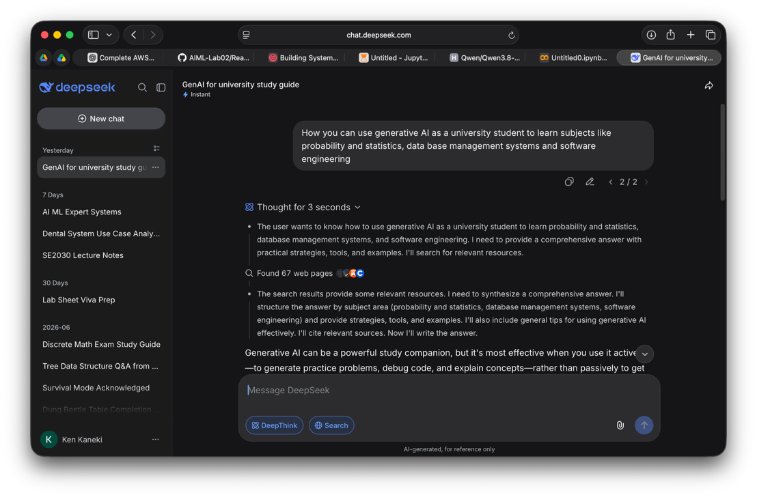
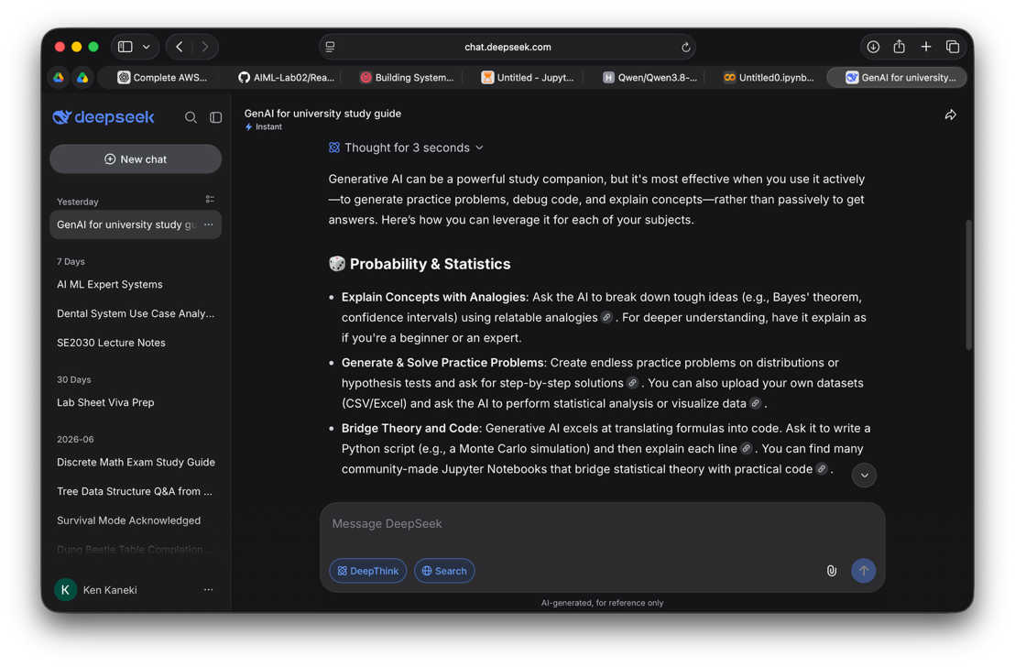

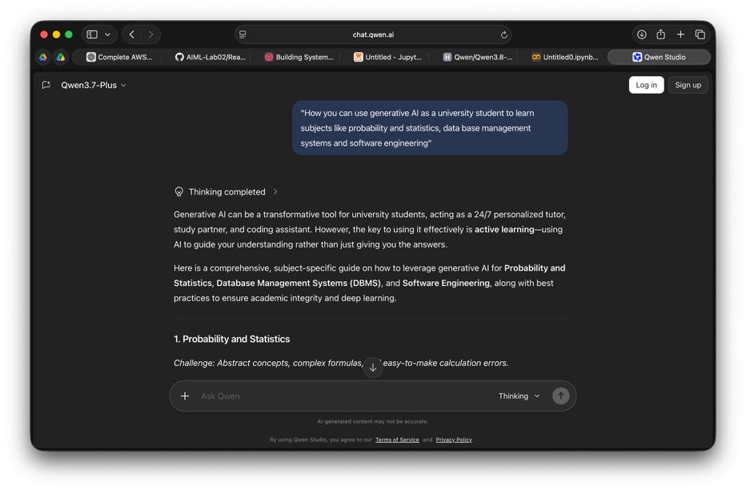
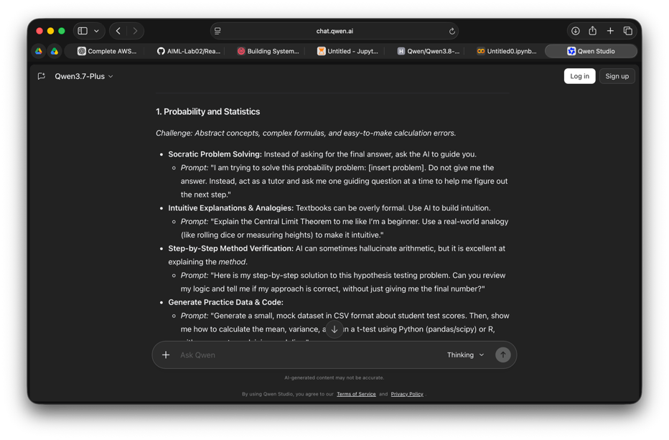
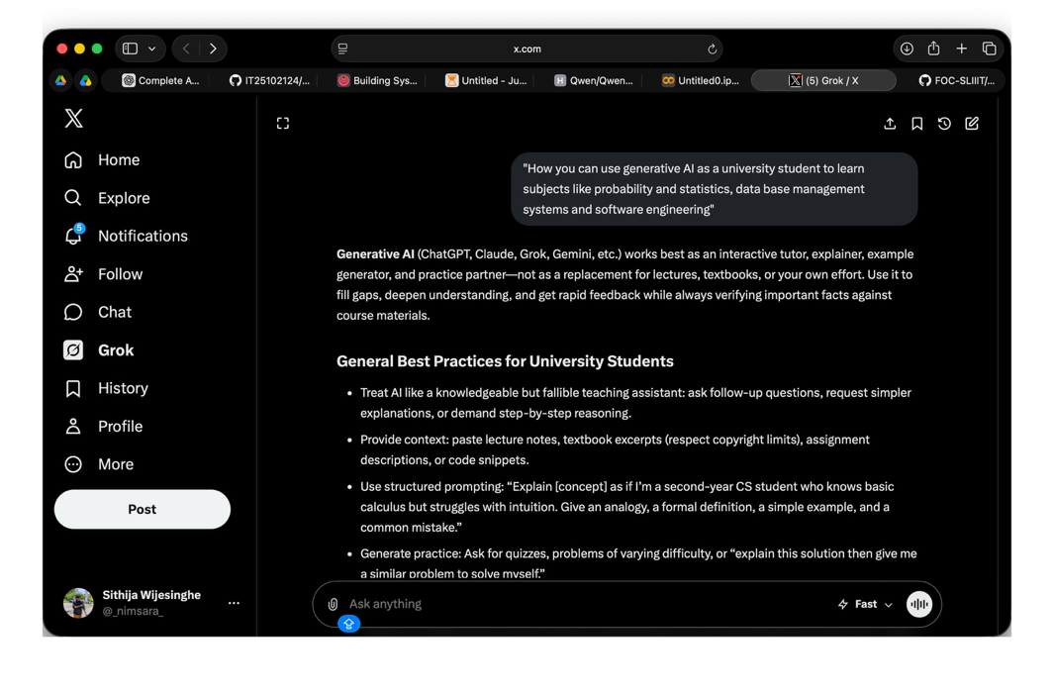
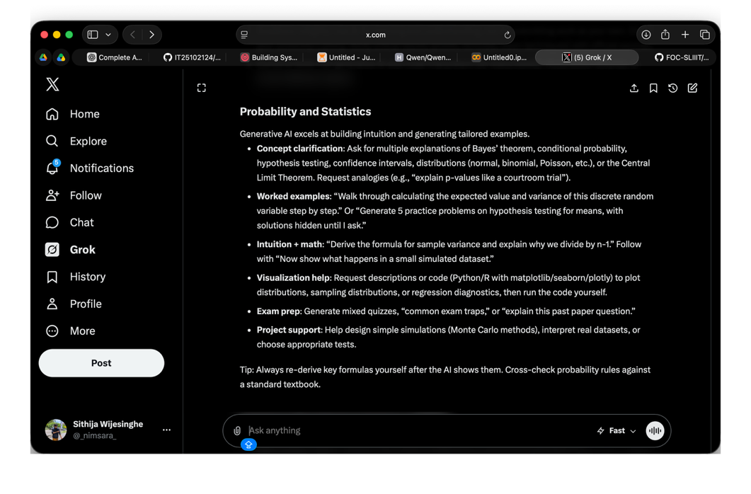
Reflection
I found that DeepSeek was the most useful tool for me. Its response was detailed and explained the topics in a way that was easy for me to understand. It also gave practical examples and useful suggestions about how students can use AI for studying. Qwen also gave a good response and provided useful information, while Grok was helpful for getting additional ideas and explanations.
One important thing I learned is that I should not depend completely on AI. Sometimes AI can give incorrect information, so I should check important answers using my lecture notes, textbooks, or other reliable sources. I also learned that AI is more useful when I give it a clear and specific prompt.

Overall, this activity showed me that Generative AI can be a useful study assistant. I can use it to explain difficult concepts, create practice questions, help with coding and SQL, and prepare for exams. However, I should use it to support my learning rather than simply copying its answers.

